ENGAGE
Faculty of Engineering, Built Environment and Information Technology
Semester Test 1
Module: JPO 152 Additional physics
14 March 2013
UNIVERSITEIT VAN PRETORIA
UNIVERSITY OF PRETORIA
YUNIBESITHI YA PRETORIA

Test information:
Marks | 75 | Total
Duration of paper: | 120 minutes | Lecturer | K Oerder
This test consists of 13 pages including this cover sheet
IMPORTANT
- The examination regulations of the university of Pretoria apply
- All questions are to be answered on this question paper.
- Please show all your working
- Formulas and Useful Constants are given on the last page

Surname: _____________________________________ Student No: _________________
Registered Degree/Field of study: ________________________________
Group: ___________________________________
Total | Q1 | Q2 | Q3 | Q4 | Q5 | Q6 | Q7
/75 | /7 | /12 | /12 | /13 | /8 | /17 | /6

Question 1 [7]
- If $\vec{a}∙\vec{b}=\vec{a}∙\vec{c}$ then is it necessarily true that $\vec{b}=\vec{c}$? Explain or give a valid counter example (3)
No. Consider $\vec{a}=1\hat{i}+1\hat{j}$ and $\vec{b}=1\hat{i}$ and $\vec{c}=1\hat{j}$ then $\vec{a}∙\vec{b}=1=\vec{a}∙\vec{c}$ but $\vec{b}≠\vec{c}$

- Describe (in three words or less) the relationship between vectors that means they have the following mathematical properties:
- $\vec{a}+\vec{b}=\vec{c}$ and $a^{2}+b^{2}=c^{2}$ (2)
perpendicular

- $\vec{a}∙\vec{b}=ab$ and $\vec{a}≠0$ and $\vec{b}≠0$ (2)
parallel

Question 2 [12]
- A motorist is travelling from town A to town B. Town B lies 30 km away from town A, in a direction 19° south of east. In order to reach town B, the motorist must however drive around a mountain range. The motorist initially drives for 55 km in a direction 30° west of north, and then turns onto another road that leads straight to town B. How far does the motorist travel along this road, and in what direction? (5)
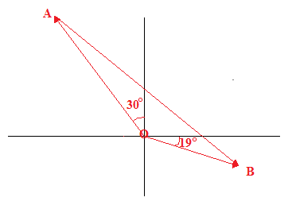
$$\vec{OA}=-55\sin{30°}\hat{i}+55\cos{30°}\hat{j}=-27.5\hat{i}+47.6\hat{j}$$
$$\vec{OB}=30\cos{19°}\hat{i}-30\sin{19°}\hat{j}=28.4\hat{i}-9.77\hat{j}$$
$$\vec{OA}+\vec{AB}=\vec{OB}$$
$$\vec{AB}=\vec{OB}-\vec{OA}=\left(28.4\hat{i}-9.77\hat{j}\right)-\left(-27.5\hat{i}+47.6\hat{j}\right)=55.9\hat{i}-57.4\hat{j}$$
$$AB=\sqrt{{AB}_{x}^{2}+{AB}_{y}^{2}}=\sqrt{{55.9}^{2}+{57.4}^{2}}=81.2 km$$
$$θ=\tan^{-1}\left(\frac{{AB}_{y}}{{AB}_{x}}\right)=\tan^{-1}\left(\frac{-57.4}{55.9}\right)=-45.8°$$
Ab is 81.2 km at 45.8° south of east

- A farmer that drank too much brandy early in the afternoon tries to plough his field on a tractor. The farmer moves four times before the tractor breaks down. The x and y components (in metres) of the four movements are:
$\vec{A}$: (30.0, 40.0) $\vec{C}$: (-20.0, $c_{y}$)
$\vec{B}$: ($b_{x}$, -70.0) $\vec{D}$: (-180, -70.0)
The vector $\vec{R}$ from the farmer’s initial position to his final position is 141 m at 172° clockwise to positive x axis
- Write out the vector $\vec{R}$ in unit vector notation (3)
$$R_{x}=R\cos{θ}=141\cos{(-42°)}=105$$
$$R_{x}=R\sin{θ}=141\sin\left(-42°\right)=-94.3$$
$$\vec{R}=105m \hat{i}-94.3m \hat{j}$$

- Find $b_{x}$ and $c_{y}$ (4)
$$\vec{R}=\vec{A}+\vec{B}+\vec{C}+\vec{D}=\left(30.0\hat{i}+40.0\hat{j}\right)+\left(b_{x}\hat{i}-70.0\hat{j}\right)+\left(-20.0\hat{i}+c_{y}\hat{j}\right)+\left(-180\hat{i}-70.0\hat{j}\right)=\left(-170+b_{x}\right)\hat{i}+(-100+c_{y})\hat{j}$$
$$105\hat{i}-94.3\hat{j}=\left(-170+b_{x}\right)\hat{i}+(-100+c_{y})\hat{j}$$
$$b_{x}=170-105=65.0m$$
$$c_{y}=100-94.3=5.7m$$

Question 3 [12]
- Two metal containers have specific heat capacity of $45 J.{kg}^{-1}K^{-1}$ and $78 J.{kg}^{-1}K^{-1}$ respectively. Which container would experience the greatest increase in temperature if an amount of heat Q is added to both containers? Explain (3)
$45 J.{kg}^{-1}K^{-1}$. $Q=mc∆T$. Higher the value for c the lower the value of ΔT for fixed value of Q.

- Many old cars still are fitted with aluminium pistons in steel cylinders. When car engines became very hot this causes a major complication. Describe this complication and why it arises. (3)
Al has a higher coefficient of volume expansion than steel. An increase in temperature will cause Al to expand more than steel. If the engine gets too hot this will cause the pistons to rupture the cylinders

- A newspaper article on recent weather events describes the temperature of an object as “the amount of heat that the object contains”. Is this description correct? Explain (3)
No. Temperature is a measure of the average internal kinetic energy of an object and is a property of the object alone. Heat is an energy transfer due to two bodies being at different temperatures. It requires two bodies to make sense and is therefore not a measurable property of a body.

- If you heat a uniform metal plate with a hole cut out of it, will the hole get smaller, bigger or remain the same size? Explain (3)
Bigger. Hole will act in same way as if metal piece was still present and the metal piece will expand when heated. If it did not then the original piece would not fit back into the hole that it is created by its removal

Question 4 [13]
- As a result of a temperature rise of 32°C, a bar with a crack at its center buckles upwards as shown below
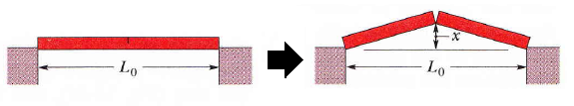
If $L_{0}=3.77 m$ and the coefficient of linear expansion of the bar is $25×{10}^{-6}{ ℃}^{-1}$, find the distance the centre of the bar rose $x$ (5)
$l_{0}=\frac{L_{0}}{2}=$ and $l=\frac{L}{2}$
$$l-l_{0}=l_{0}α∆T⇒l=l_{0}+l_{0}α∆T=1.885+1.885\left(25×{10}^{-6}\right)\left(32\right)=1.886508$$
$$x=\sqrt{l^{2}-l_{0}^{2}}=\sqrt{{1.886508}^{2}-{1.885}^{2}}=0.075 m$$

- A woman makes a 250g cup of hot coffee (boiling temperature) in a thermal flask (isolated container) with the intention of drinking it 5 minutes later. She added milk at 5°C to the flask and allows the mixture to come to thermal equilibrium.
- Draw a temperature vs time graph for the above process assuming heat transfer is at a constant rate (3)
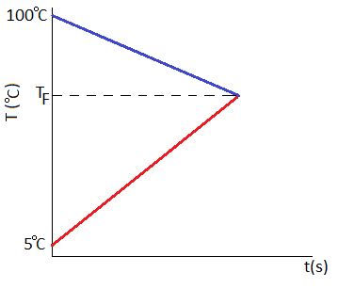
- What mass of milk needs to be added in order for the equilibrium temperature to be 50°C? (Hint: the specific heat of milk is 3.93 kJ/(kgK) (5)

$$Q_{coffee}+Q_{milk}=0$$
$$m_{coffee}c_{coffee}∆T_{coffee}+m_{milk}c_{milk}∆T_{milk}=0$$
$$m_{milk}=-\frac{m_{coffee}c_{coffee}∆T_{coffee}}{c_{milk}∆T_{milk}}$$
$$=-\frac{0.250\left(4187\right)\left(-50\right)}{3930(45)}$$
$$=0.296 kg$$

Question 5 [8]
A stack of solid copper bars, of mass 4.5 kg each, is being transported from one point to another within the recycling centre by a forklift. During the transportation process, one of the bars falls off the forklift truck into a furnace filled with molten aluminium. The copper ingot was initially at the temperature of the room (22 °C).
- How much heat must be provided to the copper in order to entirely melt the copper ingot? Show all your working. (4)
$$Q=mc∆T+mL$$
$$=4.5\left(386\right)\left(1356-295.15\right)+4.5(207000)$$
$$=2.8×{10}^{6}$$

- If the temperature of the molten aluminium in the furnace was at its melting point, would the copper ingot melt? Explain in words and by sketching a graph of temperature against time for the two metals (4)
No. Melting point of aluminium is lower than that of copper and since copper is at a lower temperature than aluminium then thermal equilibrium must be at melting point of aluminium or lower
- 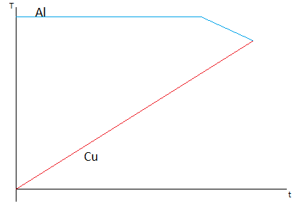
Question 6 [17]
The table below gives the sign of the initial velocity and acceleration of a particle that only moves back and forth in the x-direction in four different cases. The particle has a positive initial position in each case.
Case | Initial velocity | Initial acceleration
A | - | -
B | - | +
C | + | -
D | + | +

Describe the motion that the particle would experience in each case, including (but not limited to) whether the particle will ever be at position x=0 m and whether the particle stops momentarily. Explain your answers.
Sketch position vs time graphs for each of the situations
A) Starts off travelling in the negative direction and speeds up perpetually due to negative acceleration being in same direction as negative velocity and crosses the origin as it does so. Velocity never decreases thus it will never stop
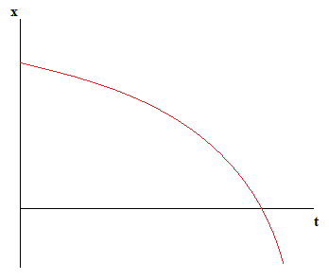
B) Starts off travelling in negative direction but slows down initially since positive acceleration is opposite to negative velocity. Eventually particle comes to a stop momentarily and changes direction of travel and moves in positive direction speeding up as it does so. The particle may (B) or may not (A) pass origin depending on magnitude of acceleration and velocity which will determine position at which object turns around
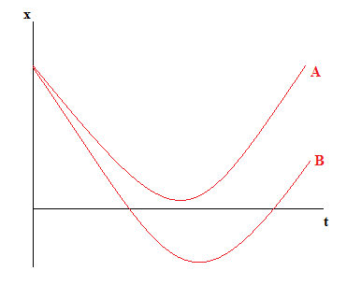
C) Starts off travelling in positive direction but slows down initially since negative acceleration is opposite to positive velocity. Eventually particle comes to a stop momentarily and changes direction of travel and moves in negative direction speeding up as it does so. Since particle is now travelling in negative direction and never stops again then it will definitely pass the origin at some stage
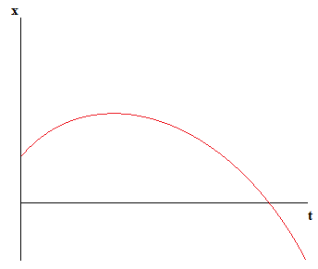

D) Starts off travelling in the positive direction and speeds up perpetually due to positive acceleration being in same direction as positive velocity and thus velocity never decreases thus it will never stop and never change direction hence never passes the origin
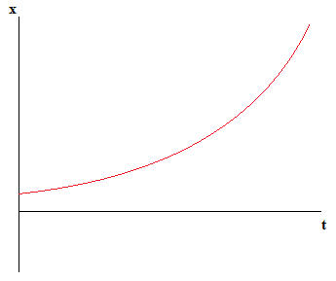

Question 7 [6]
You are at a party in your friends 3rd floor apartment building. Hanging over a balcony you spot your ex’s car and decide to get some revenge. After raiding the fridge you find some eggs and drop the first directly above the windshield of your ex’s car at the same time as you throw a second egg downwards. Which of the following curves represent the velocity for the thrown and dropped eggs? Explain your answer
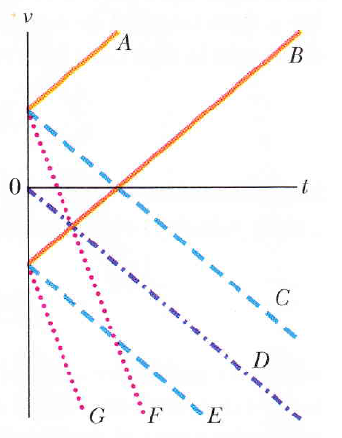
Dropped egg: D. Since dropped egg is a projectile with no initial velocity then at $t=0 s$ the graph of velocity vs time must have $v=0 m/s$ which is only graph D
Thrown egg: E. Since thrown egg is also a projectile then its acceleration is the same as the dropped egg i.e. the gradient of the velocity vs time graph is the same as that of the dropped egg: which means graph is C or E. Since egg is thrown down then there must be an initial downwards velocity to the egg which corresponds to graphs B, E, G. The common graph to these two situations is E.

Useful Information
Coefficients of Linear Expansion (K⁻¹):
Aluminium | 23x10⁻⁶ | Ice | 51x10⁻⁶
Steel | 11x10⁻⁶ | Copper | 17x10⁻⁶

Specific Heats (J kg⁻¹ K⁻¹):
Aluminium | 900 | Water | 4187
Ice | 2220 | Copper | 386
Steel | 490

Other thermodynamic information:
Substance | Melting |  | Boiling
 | Melting Point (K) | Heat of Fusion (J/kg) | Boiling Point (K) | Heat of Vaporization (J/kg)
Aluminium | 933 | 399000 | 2723 | 10530000
Water | 273 | 333000 | 373 | 2256000
Copper | 1356 | 207000 | 2868 | 4730000
Steel | 1510 | 270000 | NA | NA

Formula Sheet
$∆l=lα∆T$ $∆V=Vβ∆T$
$Q=Lm$ $Q=mc∆T$
$x-x_{0}=v_{0}t+\frac{1}{2}at^{2}$ $v=v_{0}+at$
$v_{y}^{2}={v_{0}}^{2}+2a(x-x_{0})$ $x-x_{0}=\frac{1}{2}\left(v_{0}+v\right)t$

